HES Proud Instruction Manual

Non-Editable Graphics
- Download the graphic to your computer.
- Upload the graphic to your social media profile.
- Tag #HESProud.
- LinkedIn Banner
- Facebook Cover Photo
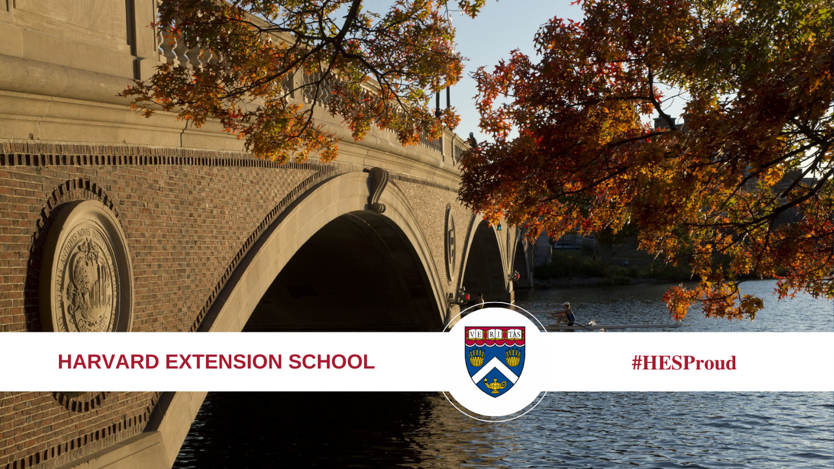
- Social Media Profile Photo (Instagram, Facebook, LinkedIn, Twitter, YouTube)
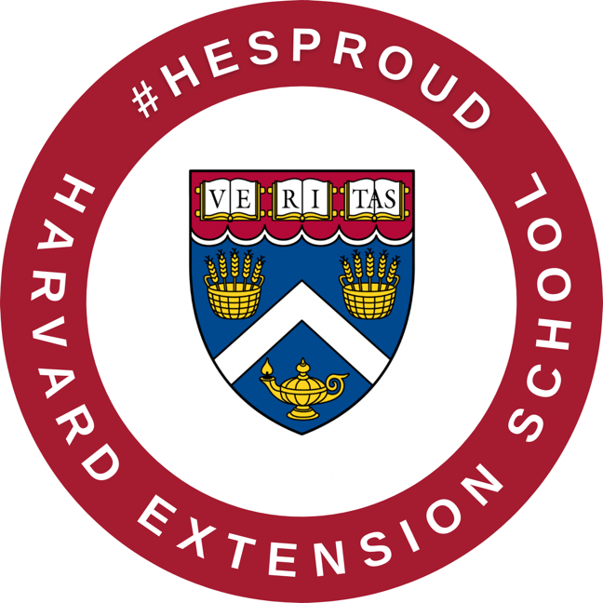

Editable Graphics:
- Download the graphic to your computer.
- Use Canva, Adobe, Microsoft Office, or a preferred editing software to personalize your graphics.
- Upload the graphic to your social media profile.
- Tag #HESProud.
- Facebook Banner – Editable
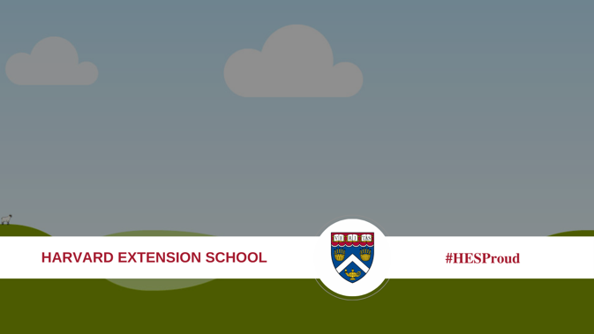
  - Canva:
    - Visit: https://www.canva.com/ and create a free profile/login to an existing profile.
    - Click create design and upload file.
    - Upload the file you downloaded to your computer. Upload a background photo you would like to use.
    - Overlay the #HESProud graphic over your chosen background photo.
    - Resize your photo and graphic if needed.
    - When you finish, click “Share” then “download” (we recommend downloading a PNG version).
    - Save your file to your computer.
    - Upload to social media and tag us with #HESProud.
  - Adobe Photoshop
    - Drag the file into Adobe Photoshop to create a new file.
    - Add a personal photo and adjust to the full size of the file.
    - Click “Layers” on the right menu.
    - Drag your new photo layer below layer one.
    - Adjust your image and graphic if needed.
    - Save the file and export it as a PNG/JPG.
    - Upload to social media and tag us with #HESProud.
- Social Media Profile Photo (Instagram, Facebook, LinkedIn, Twitter, YouTube) – Editable
  - Canva
    - Visit: https://www.canva.com/ and create a free profile/login to an existing profile.
    - Click create design and upload file.
    - Upload and adjust a personal photo. Click the three dots and press “replace background.”
    - Insert the #HESProud graphic over your photo and adjust as needed.
    - When you finish, click “Share” then “download” (we recommend downloading a PNG version).
    - Save your file to your computer.
    - Upload to social media and tag us with #HESProud.
  - Adobe Photoshop
    - Drag the file into Adobe Photoshop to create a new file.
    - Add a personal photo and adjust to the full size of the file.
    - Click “Layers” on the right menu.
    - Drag your new photo layer below layer one.
    - Adjust your image and graphic if needed.
    - Save the file and export it as a PNG/JPG.
    - Upload to social media and tag us with #HESProud.
- Instagram Text Graphic- Editable
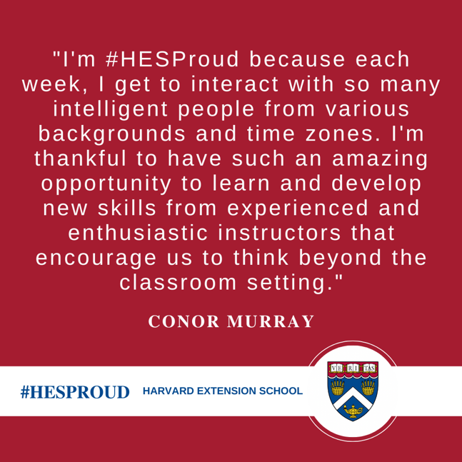
  - Canva
    - Visit: https://www.canva.com/ and create a free profile/login to an existing profile.
    - Click create design and upload file.
    - Click “text” then “Add a text box.”
    - Type your desired content.
    - When you are finished, click “Share” then “download” (we recommend downloading a PNG version).
    - Save your file to your computer.
    - Upload to social media and tag us with #HESProud.
  - Adobe Photoshop
    - Drag the file into Adobe Photoshop to create a new file.
    - Click the “T” symbol on the left menu.
    - Personalize the graphic with your own text.
    - Save the file and export it as a PNG/JPG.
    - Upload to social media and tag us with #HESProud.
- Instagram Image Graphic- Editable
  - Canva
    - Visit: https://www.canva.com/ and create a free profile/login to an existing profile.
    - Click create design and upload file.
    - Upload the file you downloaded to your computer. Upload a background photo you would like to use.
    - Overlay the #HESProud graphic over your chosen background photo.
    - Resize your photo and graphic if needed.
    - When you are finished, click “Share” then “download” (we recommend downloading a PNG version).
    - Save your file to your computer.
    - Upload to social media and tag us with #HESProud.
  - Adobe Photoshop
    - Drag the file into Adobe Photoshop to create a new file.
    - Add a personal photo and adjust to the full size of the file.
    - Click “Layers” on the right menu.
    - Drag your new photo layer below layer one.
    - Adjust your image and graphic if needed.
    - Save the file and export it as a PNG/JPG.
    - Upload to social media and tag us with #HESProud.

